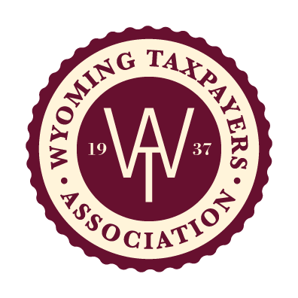
Wyoming Taxpayers Association
Exemption Justification Analysis
 

Wyoming Taxpayers Association (WTA) believes sound tax policy is framed by a tax structure that is justified, equitable, stable and transparent. We start with the premise that policymakers imposed taxes for a purpose. We suggest that exemptions to imposed taxes have been adopted for multiple reasons, such as:
- Some act as an incentive to drive economic development.
- Some exist out of necessity for an efficient tax system.
- Some ease administration and collection.
- Some are preempted by the state and federal Constitutions.
- Some prevent tax pyramiding.
WTA recognizes the tool that exemptions can play in building a sound, viable economy for Wyoming, but WTA also recognizes exemptions are a privilege to conducting commerce. We further recognize exemptions may erode the existing tax base thereby creating pressure to seek other revenue sources. As such, existing and proposed exemptions should be scrutinized for the long-term effects on overall revenue collections. Just as new taxes or increases in existing taxes should meet a Cornerstones Analysis, we believe that existing and new exemptions should be analyzed on the merits to be included in Wyoming’s tax structure.
WTA believes sound tax policies are the foundation from which economic development and prosperity can grow.

The WTA Government Affairs Committee, at its discretion, will accept an Exemption Justification Analysis from any member on a draft bill or sponsored bill. Submit supporting materials with completed Exemption Justification Analysis to WTA Executive Director, Ashley Harpstreith, via email ashley@wyotax.org.
Section I – General Information
Please provide the following information for discussion.
Date: ___________ Bill Number: __________________ Bill Title: _______________________________

Position requested: _____SUPPORT _____OPPOSE

Presented by: Representing:

Legislative Committee: Sponsor(s):

Brief summary/history of proposal:

Section II – Exemption Justification Analysis
Please answer each question thoroughly. WTA encourages thoughtful answers that are concise in nature.
Justified:
Is the exemption JUSTIFIED?
What measurable benefits and return on investment will the citizens of Wyoming gain?
Does the exemption have a reasonable sunset and/or claw back provisions?
Equitable:
Is the exemption EQUITABLE?
Does the exemption disadvantage one taxpayer over another?
Does the exemption create pressure to increase taxes on other taxpayers?
Stable:
Is the exemption STABLE?
Do the benefits of the exemption outweigh or offset a sustained loss of tax revenue created by the exemption?
Will the exemption provide opportunity to diversify the economy and in due time expand the tax base?
Transparent:
Is the exemption TRANSPARENT, accountable and auditable?
Is the exemption efficient to administer and enforce?
How will benefits and effects of the exemption be measured?
What public reporting is required and who is accountable?

