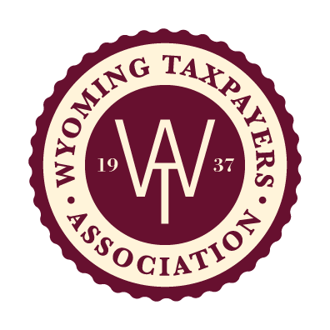

Consensus Revenue Estimating Group
Wyoming State Government Revenue Revision
Fiscal Year 2023 – 2028

The Consensus Revenue Estimating Group (CREG) released the January 2023 Wyoming State Government Revenue Forecast for Fiscal Year (FY) 2023 - 2028 on January 12, 2023. Co-Chair Don Richards reported this revised forecast was limited to FY 2023 through FY 2024 but included four major revisions to the October Report: 1) modified natural gas prices with an increase for calendar year 2022 of $00.40 to $7.40/Mcf and a decrease of $00.15 to $5.75/Mcf for calendar year 2023; 2) a decrease of $99.9 million investment income to the Permanent Wyoming Mineral Trust Fund (PWMTF); 3) a decrease of investment income of $67.8 million to the Common School Permanent Land Fund (CSPLF); and 4) an increase to the state royalties by $15 million because of known receipts. Per the report, “all other revenue streams and assumptions remain unchanged”. All major changes can be found on page 7 of the Fiscal Profile. Note the CREG does not include capital gains in the forecast. 